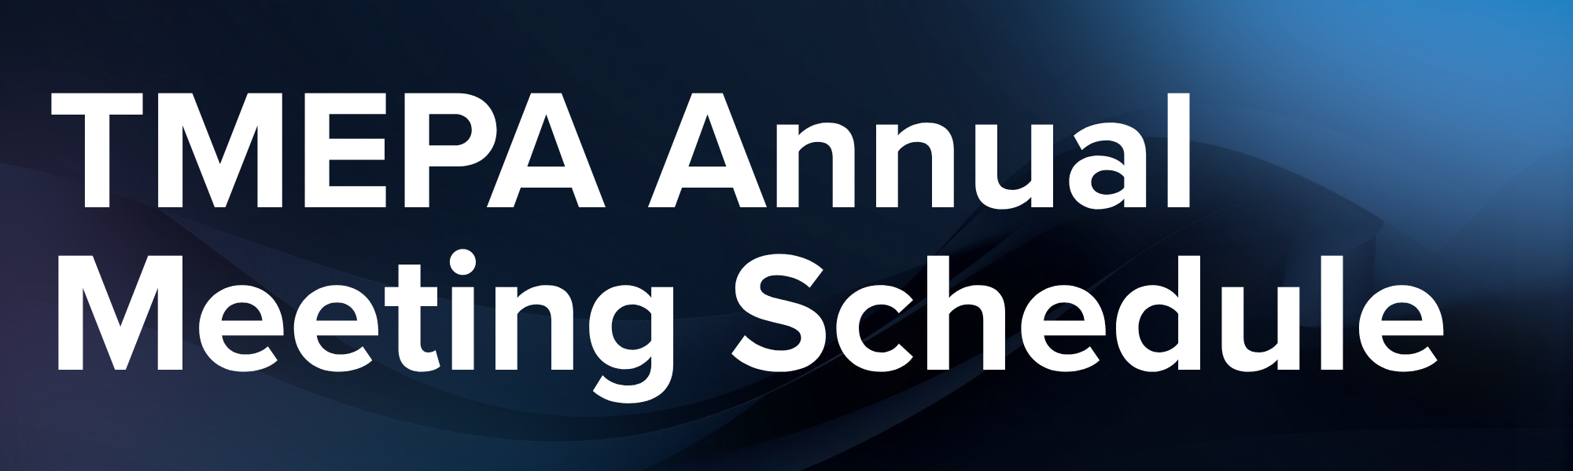
Wednesday, July 15
8:00 | Shotgun start Golf Tournament at Egwani Farms  Breakfast served at 7:00am
1:00-5:00 | Vendor Load-In & Registration / Check-In
6:00-9:00 | Welcome Reception & Dinner featuring Confederate Railroad
The Mill & Mine
Transportation departs from Knoxville Convention Center starting at 5:45pm.
Thursday, July 16
7:30 | Registration and Check-In - Ballrooms ABCD
7:30 | Buffet Breakfast - Ballrooms ABCD
8:30 | Welcoming Remarks
9:00 | Federal Energy Policy and Tennessee  Scott Corwin, APPA
9:30-10:30 | Spouse Event - Sunsphere  Gather at the Marriott Downtown Knoxville Lobby to begin the tour. Beverages and light snacks provided.
9:30 | Break - Exhibit Hall
10:00 | Leadership Lessons from a Legendary Coach  Coach Rick Barnes, University of Tennessee
10:30 | Political Engagement - The View from The Hill  Senator Richard Briggs, Representative John Crawford & Steve Buttry, The Capital Strategy Group. Erin Gill, Moderator.
11:30 | Distinguished Service Awards Lunch - Ballroom E
1:00 | The Intersection of Sports, Culture, and Media  Chris Low, On3
1:30 | Crisis Management: Before, During, and After the Storm  Todd Womack & Austin Cantrell, Bridge Public Affairs
2:00 | Tennessee Legislative Report  Jeremy Elrod, TMEPA and Mark Smith, Miller & Martin
2:30 | Ice Cream Sundae Break - Exhibit Hall
3:00 | Advanced Energy Solutions to Meet Growing Demand  Aron Bowman, ELM Microgrid, Tyler Mauldin, Google & Madhu Chinthavali, ORNL
3:45 | TMEPA Business Meeting
4:45 | Adjourn First Session
 | TEPAC Annual Meeting
5:00-6:30 | Networking Reception & Karaoke
6:30 | Silent Auction Closes
 | Dinner on Your Own
Friday, July 17
7:30 | Buffet Breakfast - Ballrooms ABCD
8:30 | Get On or Get Off – This Bus Is Rolling!  Privott Stroman, TMEPA
9:30 | Congressional Perspective  Congressman Chuck Fleischmann
10:00 | Break - Exhibit Hall
10:30 | Quantum: An Electric Utility Solution  Janet Rehberg, EPB of Chattanooga & Ryan Harring, IonQ
11:15 | TVA Vision and Perspective  Mike Skaggs, TVA
Wednesday, July 15
6:00-9:00 Welcome Reception & Dinner
The Mill & Mine
Thursday, July 16
7:30 Registration and Check-In - Ballrooms ABCD
7:30 Buffet Breakfast - Ballrooms ABCD
8:30 Welcoming Remarks
9:00 Federal Energy Policy and Tennessee
9:30-10:30 Spouse Event - Sunsphere
9:30 Break - Exhibit Hall
10:00 Leadership Lessons from a Legendary Coach
10:30 Political Engagement - The View from The Hill
11:30 Distinguished Service Awards Lunch - Ballroom E
1:00 The Intersection of Sports, Culture, and Media
1:30 Advanced Energy Solutions to Meet Growing Demand
2:15 Tennessee Legislative Report
2:45 Ice Cream Sundae Break - Exhibit Hall
3:15 Crisis Management: Before, During, and After the Storm
3:45 TMEPA Business Meeting
4:45 Adjourn First Session
TEPAC Annual Meeting
5:00-6:30 Networking Reception & Karaoke
6:30 Silent Auction Closes
Dinner on Your Own
Friday, July 17
7:30 Buffet Breakfast - Ballrooms ABCD
8:30 Get On or Get Off – This Bus Is Rolling!
9:30 Quantum: An Electric Utility Solution
10:15 Break - Exhibit Hall
10:45 TVA Vision and Perspective
11:30 Closing Remarks

